




Assessing Occupational Burnout Among Teachers in Lucknow City
A Multi-Factor Study Using the Burnout Assessment Tool (BAT)

Project Domain
Microsoft Excel + Power BI+ Microsoft Copilot

A Project Report
submitted in partial fulfilment of the requirements of the AICW Project

by:



S Email
Drkritika.nationalpgcollege@npgc.in
Faculty Name
Dr. Kritika Malhotra
Guide
Umamaheshwari R

Institution:
National P.G. College, Lucknow

Year - 2026
ACKNOWLEDGEMENT

I would like to take this opportunity to express my deep sense of gratitude to all individuals who helped me directly or indirectly during this project work.

Firstly, I would like to thank my supervisor, Umamaheshwari R for being a great mentor and the best adviser we could have asked for. Her advice, encouragement, and constructive feedback served as a source of innovative ideas and inspiration, and were central to the successful completion of this project. The confidence shown in me was the biggest source of motivation throughout this journey. I extend my sincere thanks to the Edunet Foundation, Microsoft, LinkedIn, and SAP for providing this fellowship opportunity, the learning resources, and the platform to learn, develop and showcase my AI skills.

I am also grateful to our institution, National PG College, for providing the necessary infrastructure and support throughout the project duration. Finally, I thank my family and friends for their continuous encouragement and support.
.

ABSTRACT OF THE PROJECT
Occupational burnout among teachers has become an increasingly critical concern within higher education, yet systematic assessment frameworks remain limited across Indian academic institutions. This study assesses burnout among 54 teachers from multiple streams in Lucknow City using the Burnout Assessment Tool (BAT)—a globally validated multidimensional instrument that measures core symptoms (exhaustion, mental distance, emotional impairment, cognitive impairment) and secondary symptoms (psychological distress, psychosomatic complaints) and WHO Well-Being Index
A cross-sectional, quantitative design was employed. Data were analysed using descriptive statistics, Pearson correlations, and ANOVA. Visualisation and AI-assisted summarization were performed using Microsoft Excel, Power BI, and Microsoft Copilot. Comparative results revealed significant differences in burnout across academic streams. Psychosomatic complaints (p = .001) and cognitive impairment (p = .006) varied notably by stream, with the strongest effects observed among Humanities and Commerce faculty. Emotional impairment and psychological distress showed emerging trends, though not statistically significant. Mean score analysis further indicated that Humanities teachers reported higher psychosomatic and cognitive strain compared to Science stream teachers, who consistently scored the lowest across burnout dimensions. WHO-5 Well-Being visualizations indicated moderate levels of subjective well-being overall, but reduced freshness, relaxation, and vitality among high-burnout groups.
The study concludes that burnout among teachers in Lucknow is multi-factorial, with meaningful variation across academic specializations. These findings highlight the urgent need for institutional interventions such as workload rationalization, structured wellness programs, counseling support, and AI-enabled early risk detection. By integrating validated psychometric testing with modern analytics platforms, this project demonstrates a scalable model for educational institutions seeking data-driven strategies to safeguard faculty well-being and prevent long-term professional exhaustion.

TABLE OF CONTENTS
Abstract of the Project
List of Figures
List of Tables
Chapter 1 — Introduction
1.1 Problem Statement
1.2 Motivation
1.3 Objectives
1.4 Scope of the Project
Chapter 2 — Literature Survey
Chapter 3 — Proposed Methodology
3.1 System Design
3.2 Modules / Components Used
3.3 Data Flow Diagram (DFD)
3.4 Advantages
3.5 Requirement Specification
Chapter 4 — Implementation and Results
4.1 Data Cleaning Results
4.2 Visualization / Output Results
4.3 AI Tool Integration Results
Chapter 5 — Discussion and Conclusion
References
LIST OF FIGURES

Figure No. | Figure Title / Description | Page No.
 | DFD 0 | 12
 | DFD 1 | 12
Figure 1 | Raw dataset | 15
Figure 2 | Cleaned dataset | 16
Figure 3 | Power BI Dashboard | 17
Figure 4 | WHO Wellbeing Index | 17
Figure 5 | Chatbot Agent | 18
Figure 6 | Correlation between BAT Vs. Stream | 20
Figure 7 | ANOVA | 20

LIST OF TABLES

Table No. | Table Title / Description | Page No.
Table 1 | Hardware Requirements | 13
Table 2 | Software Requirements | 14
Table 3 | Cronbach Alpha | 16

CHAPTER 1
Introduction
Teacher burnout — defined as physical and emotional exhaustion from prolonged occupational stress — is a growing crisis in higher education. At a multi-stream institution, teachers across Science, Arts, Commerce, Social Sciences, and Humanities face varying workloads and pressures, yet no structured burnout assessment currently exists. This project addresses that gap by administering the globally validated Burnout Assessment Tool (BAT) to 54 teachers, measuring burnout across all its dimensions, and generating evidence-based recommendations for institutional intervention.
  - Problem Statement
In most academic institutions, including multi-stream colleges in India, faculty members contribute across a wide range of activities — from delivering lectures and supervising research to managing administrative responsibilities and mentoring students. Despite this breadth, there is rarely a structured mechanism to assess, document, or compare the psychological toll of these responsibilities in a standardised way. Existing approaches fail to surface deeper patterns — such as whether certain streams carry disproportionately higher burnout risk, which faculty are at risk of emotional or cognitive impairment, or whether workload-related stress is manifesting in psychosomatic symptoms. These are not minor concerns; they directly affect faculty retention, teaching quality, and institutional reputation.

This project specifically addresses the following gaps at various colleges in the city:
- Absence of a validated, structured burnout assessment for teaching staff across all academic streams.
- Lack of analytical depth to identify faculty/streams experiencing emotional impairment, cognitive decline, mental distancing, or psychosomatic symptoms as a result of occupational stress.
- No comparative data to identify which departments carry the highest burnout burden, making it impossible for administration to direct welfare resources effectively.
- No AI-assisted mechanism to generate burnout summaries, flag at-risk faculty, or produce actionable recommendations for institutional well-being planning.
1.2 Motivation
The motivation behind selecting this project arises from its strong personal relevance and real-world importance in addressing the growing issue of teacher burnout in higher education. Faculty members today face increasing demands from teaching, research, administrative duties, and student engagement, yet there is a clear lack of structured and data-driven mechanisms to assess and manage burnout within academic institutions. This gap made the topic both professionally meaningful and impactful, as burnout directly affects teacher well-being, performance, and institutional effectiveness. The project is further motivated by its practical applications, enabling institutions to identify burnout levels and implement targeted interventions such as workload management, counselling support, and wellness programs. Additionally, it aligns with modern trends in AI and data analytics, integrating tools like Excel, Power BI, and Copilot to support evidence-based decision-making. Overall, the project is driven by the goal of combining analytical techniques with real-world problem-solving to improve faculty well-being and demonstrate the value of data-driven and AI-enabled solutions in the education sector.
1.3 Objectives
- To collect and understand the structure and characteristics of the dataset used in the study, including variables related to teacher workload, burnout, and well-being.
- To clean and pre-process the raw data by removing duplicates, handling missing values, and ensuring proper formatting for accurate analysis.
- To apply domain-specific statistical and analytical techniques using tools such as Microsoft Excel, Power BI, and AI-based platforms (e.g., Copilot and Copilot Studio) to examine burnout patterns among teachers.
- To assess the internal consistency reliability of the Burnout Assessment Tool (BAT) subscales using Cronbach’s Alpha (α), ensuring a minimum acceptable threshold of 0.70.
- To perform comparative analysis using statistical methods such as ANOVA to identify differences in burnout levels across academic streams, departments, and workload categories.
- To develop interactive dashboards and visual reports that effectively communicates key findings and burnout patterns.
- To leverage AI tools such as Microsoft Copilot and chatbots to automate analysis, generate insights, and enhance report writing.
- To provide data-driven recommendations for institutional interventions aimed at reducing burnout and improving teacher well-being.
1.4 Scope of the Project
- The project analyses a structured dataset related to teacher burnout and workload in higher education institutions.
- The dataset includes responses based on standardized tools such as BAT, MBI-ES, and WHO-5 Well-Being Index.
- Tools used in the project include Microsoft Excel, IBM SPSS, Power BI, and AI tools like Microsoft Copilot and chatbots.
- The project focuses on data cleaning and preprocessing to ensure accuracy and reliability of the dataset.
- Statistical analysis techniques such as Cronbach’s Alpha, correlation, and ANOVA are used for data analysis.
- The study includes visualization of burnout patterns across different academic streams using dashboards and charts.
.

CHAPTER 2
Literature Survey
2.1 Literature Review
Teacher burnout has been widely recognized as a significant psychological and occupational issue, particularly within the education sector. Early conceptualizations of burnout by Friedman (2000) describe it as the “shattering of professional ideals,” where teachers experience a gradual loss of motivation, emotional energy, and commitment due to prolonged exposure to job-related stress. Similarly, Chang (2009) emphasizes the emotional dimension of teaching, arguing that burnout is closely linked to teachers’ appraisal of classroom situations and their ability to regulate emotions. This perspective highlights that burnout is not merely a result of workload but is deeply rooted in the emotional labour inherent in teaching. Over time, these emotional demands can lead to exhaustion, reduced efficacy, and disengagement from professional responsibilities.
The multidimensional nature of burnout has been further explored through empirical studies in higher education. Teles et al. (2020) identify burnout as a consequence of chronic occupational stress, affecting both physical and psychological well-being, and ultimately reducing teaching quality and increasing absenteeism. Their findings also suggest that demographic and professional variables, such as age, gender, and job stability, play a crucial role in determining burnout levels. Similarly, Kabanova et al. (2020) highlight the growing pressures on faculty members due to increased institutional demands, which contribute to emotional exhaustion and deteriorating mental health. These studies collectively emphasize that burnout is influenced by a combination of individual, organizational, and socio-professional factors.
Recent research has expanded the understanding of burnout by linking it with overall well-being. Pakdee et al. (2025) demonstrate that burnout is strongly associated with reduced well-being among higher education teachers, with factors such as workload, working hours, and work experience significantly influencing different dimensions of burnout. The study also underscores the importance of early identification and monitoring of burnout symptoms to prevent long-term negative outcomes. In this context, well-being measures such as the WHO-5 Well-Being Index (Bech, 2004) have gained prominence, as they provide a reliable way to assess subjective well-being and establish its inverse relationship with burnout.
Measurement of burnout has evolved significantly over the years, with the Maslach Burnout Inventory—Educators Survey (MBI-ES) developed by Maslach, Jackson, and Schwab (1996) being the most widely used tool. The MBI conceptualizes burnout through three core dimensions: emotional exhaustion, depersonalization, and reduced personal accomplishment. While the MBI has contributed extensively to burnout research, it has certain limitations, particularly its inability to capture cognitive and psychosomatic aspects of burnout comprehensively. To address these limitations, newer instruments such as the Burnout Assessment Tool (BAT) have been developed. Schaufeli, Desart, and De Witte (2020) introduced the BAT as a more comprehensive framework that includes both core dimensions—exhaustion, mental distance, emotional impairment, and cognitive impairment—and secondary dimensions such as psychological distress and psychosomatic complaints.
The BAT has been validated across different contexts, including among teachers, where it has demonstrated high reliability and strong psychometric properties. Angelini et al. (2021) provide empirical support for the BAT, showing that it offers a multidimensional and integrative approach to burnout assessment. Unlike traditional tools, the BAT generates a single composite burnout score while also capturing the complexity of burnout through its multiple dimensions. Importantly, the inclusion of cognitive impairment addresses a significant gap in earlier models, as cognitive difficulties such as reduced concentration and memory are increasingly recognized as critical components of burnout.
Despite the advancements in burnout research and measurement, several gaps remain in the literature. Most studies have been conducted in Western or European contexts, with limited focus on developing countries such as India. Furthermore, there is a lack of structured institutional assessment systems that can systematically evaluate burnout across departments and academic streams. Existing research also tends to rely on traditional statistical approaches, with minimal integration of data analytics and AI-based tools for deeper insights and real-time monitoring. These limitations highlight the need for context-specific, data-driven studies that can provide actionable insights for educational institutions.
In this regard, the present study by Malhotra (2026) seeks to address these gaps by assessing occupational burnout among teachers in Lucknow city using the Burnout Assessment Tool (BAT). By integrating the BAT with the MBI-ES for convergent validity and the WHO-5 Well-Being Index for discriminant validity, the study aims to provide a comprehensive and reliable assessment of burnout. Additionally, the use of statistical techniques such as Cronbach’s alpha, Pearson correlation, and ANOVA, along with data visualization tools, enables a more analytical and comparative approach to understanding burnout across academic streams. This study contributes to the existing literature by offering a localized, multidimensional, and data-driven perspective on teacher burnout in the Indian higher education context.
2.2 Tools and Technologies Review
a) The Burnout Assessment Tool (BAT)- It represents a significant advancement in the measurement of burnout. Unlike traditional tools, the BAT incorporates both core and secondary dimensions, providing a more comprehensive understanding of the burnout phenomenon. The core dimensions include exhaustion, mental distance, emotional impairment, and cognitive impairment, while the secondary dimensions encompass psychological distress and psychosomatic complaints. This multidimensional structure allows the BAT to offer a holistic assessment of burnout, along with a single composite score for overall evaluation. Importantly, the inclusion of cognitive impairment addresses a key limitation of earlier instruments, which often overlooked this critical aspect of burnout.
b) WHO Well-Being Index- In addition, the WHO-5 Well-Being Index is widely used to measure subjective well-being and has been shown to have a negative correlation with burnout, indicating that higher burnout levels are associated with lower well-being. In the context of this study, the WHO-5 is utilized to establish discriminant validity, ensuring that burnout is measured as a construct distinct from general well-being.
c) Other tools used:
- Microsoft Excel used for data cleaning, transformation, and basic visualization. Karl Pearson’s Correlation Coefficient and ANOVA was used.
- Microsoft Power BI is a business analytics tool that provides interactive visualizations an interface simple enough to create dashboards for demographic factors and WHO Well-being index.
- Microsoft Copilot (AI) an AI assistant tool was used to automate tasks, generate summaries, and assist with data analysis using natural language prompts.
- AI Chatbots is a generative AI tools used for content creation, marketing copy, report generation, and prompt-driven analysis.

2.3 Gaps Identified
The gaps that are identified after studying the already preset literature are:
- Lack of structured institutional assessment systems – Especially in the Indian context, with no standardized mechanisms to measure burnout across departments, making it difficult to identify high-risk groups or implement timely interventions.
- Over-reliance on traditional tools (e.g., MBI) – Existing tools do not adequately capture key dimensions such as cognitive impairment, psychosomatic symptoms, or provide a composite burnout score.
- Limited comparative analysis – Few studies compare burnout across academic streams, departments, or workload categories, limiting the design of targeted, evidence-based interventions.
- Absence of data-driven and AI-based approaches – Most research uses conventional statistical methods, failing to integrate modern tools like Excel-based analytics, statistical modeling, or AI-assisted insights for deeper analysis or real-time monitoring.
- Insufficient focus on the Indian higher education context – The majority of empirical studies are set in Western or European contexts, reducing applicability to Indian institutions.
- Lack of localized research (e.g., at the city level) – No focused studies in cities like Lucknow, further limiting the relevance and transferability of existing findings to Indian academic settings.

.
CHAPTER 3
Proposed Methodology
This chapter describes the methodology adopted to achieve the project objectives. It covers the system design, modules used, data flow, advantages, and requirement specifications.
3.1 System Design
Describe the overall design approach of your project. Explain how data flows from input to output in your system.
- Data Source / Input: The data for this study was collected through a structured questionnaire distributed using Google Forms. The questionnaire was designed to measure teacher burnout using standardized instruments such as the Burnout Assessment Tool (BAT), along with related variables. Initially, responses were collected from a total of 68 teachers across different academic streams. The raw dataset was then exported into Microsoft Excel for further processing and analysis.
- Data Cleaning: Data cleaning was performed to ensure accuracy and reliability of the dataset. Duplicate responses were identified and removed, and incomplete or inconsistent entries were excluded from the analysis. Missing values were carefully handled, and responses were standardized into numerical formats suitable for statistical analysis. After the cleaning process, the final sample size was reduced to 54 valid responses, which were used for further analysis.
- Analysis / Processing: The cleaned dataset was analyzed using a combination of tools and techniques. Microsoft Excel was used for initial data organization, coding, and basic analysis such as calculating averages and preparing variables. IBM SPSS was used for advanced statistical analysis, including reliability testing (Cronbach’s Alpha), correlation analysis, and ANOVA to examine differences across groups. Additionally, Microsoft Copilot was utilized to assist in data interpretation, content generation, and improving the analytical process. AI-based tools were also used to streamline analysis and enhance efficiency.
- Visualization / Output: The results of the analysis were presented through clear and interactive visualizations using Microsoft Power BI. Dashboards were created to display burnout levels across different dimensions and academic streams, making it easier to interpret patterns and insights. Charts, graphs, and summary reports were developed to effectively communicate findings. Furthermore, Microsoft Copilot Studio was used to create a chatbot interface that can provide insights and interact with users based on the ounsell data. The final output includes a comprehensive analytical report along with visual dashboards that support data-driven decision-making.
3.2 Modules / Components Used

Module 1 — Data Ingestion: Data was collected using Google Forms (68 responses) and imported into Microsoft Excel.

Module 2 — Data Cleaning: Duplicates and incomplete responses were removed, and data was standardized. Final sample size: 54.

Module 3 — Data Analysis: Data was ounsell using Excel and SPSS (Cronbach’s Alpha, correlation, ANOVA) with support from Copilot.

Module 4 — Visualization / Report Generation: Interactive dashboards and charts were created using Power BI along with summary reports.

Module 5 — AI Integration:Copilot was used for analysis and report writing, and Copilot Studio was used to build a chatbot.

3.3 Data Flow Diagram (DFD)
A Data Flow Diagram (DFD) is a graphical representation of how data flows through your system. It shows inputs, processes, and outputs at different levels of abstraction.
DFD Level 0 — Context Diagram
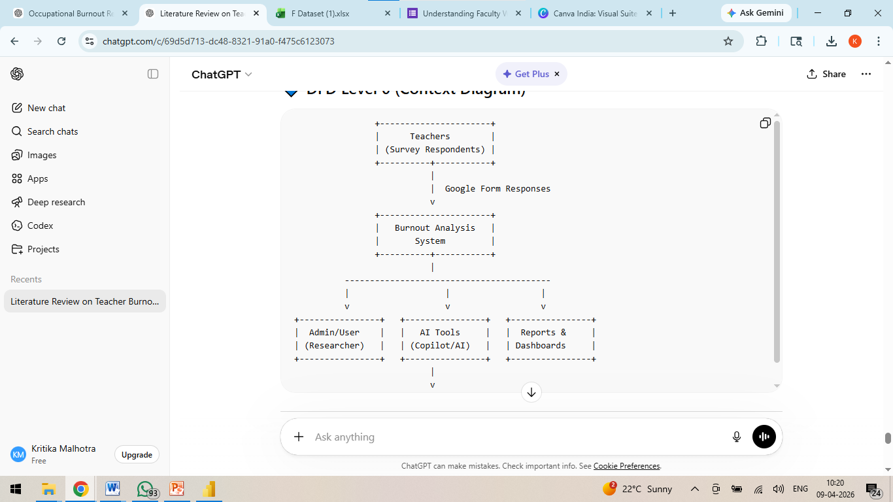
DFD Level 1 — Detailed Process Flow
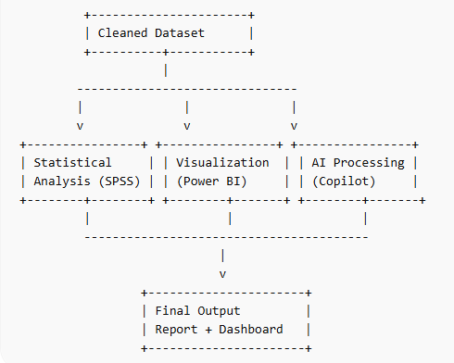
3.4 Advantages
- Provides a comprehensive understanding of teacher burnout using a multidimensional approach through the Burnout Assessment Tool (BAT).
- Helps in identifying key burnout factors such as exhaustion, emotional impairment, and cognitive impairment among teachers.
- Enables institutions to recognize high-risk groups and take timely interventions to improve faculty well-being.
- Offers data-driven insights that support effective decision-making in academic institutions. Incorporates statistical analysis (Cronbach’s Alpha, correlation, ANOVA), ensuring reliability and validity of results.
- Utilizes modern tools like Excel, SPSS, Power BI, and AI platforms, making the research practical and industry-relevant.
- Bridges the research gap in the Indian higher education context, particularly at the city level (Lucknow).
- Enhances awareness about mental health and workplace stress in the education sector.
- Provides a scalable framework that can be applied to other institutions or domains.
- Supports the development of targeted strategies such as workload management, ounselling, and wellness programs.
3.5 Requirement Specification
Hardware Requirements
Component | Specification
Processor | Intel ® Core TM i3-4010 CPU@1.70 GHz
RAM | 8 GB
Storage | 224 GB
Display | 1366 x 768 resolution or higher
Internet | 144/72 Mbps
Table 1
Software Requirements
Software | Details
Operating System | Windows 10
Microsoft Excel | Microsoft Office 2010
Power BI Desktop | Power BI Desktop (free download from Microsoft)
Microsoft Copilot | copilot.microsoft.com
AI Chatbot | ChatGPT / Microsoft Copilot (web)
Web Browser | Google Chrome and Microsoft Edge

Table 2
CHAPTER 4
Implementation and Results
This chapter presents the actual implementation of the project and the results obtained at each stage. Screenshots of dashboards, cleaned datasets, or generated content should be inserted where indicated.
4.1 Data Cleaning Results
• Dataset Source: The dataset was collected through a Google Forms questionnaire distributed among teachers from different academic streams. The responses were manually collected and exported into Microsoft Excel and Power BIfor analysis.
• Original Dataset Size: The raw dataset consisted of 68 rows and 50 columns, where each row represented an individual respondent.
• Issues Found: Several issues were identified in the raw dataset, including duplicate responses, incomplete entries, missing values, and inconsistencies in response format (such as categorical text responses requiring numerical coding).
• Cleaning Steps Applied: Data cleaning was performed using Microsoft Excel. Duplicate entries were removed, and incomplete or invalid responses were excluded. Missing values were handled appropriately, and categorical responses were standardized and converted into numerical formats for statistical analysis. Data consistency and formatting were also checked and corrected.
• Cleaned Dataset Size: After the cleaning process, the final dataset consisted of 54 rows and 50 columns, ensuring that only valid and complete responses were included for further analysis.

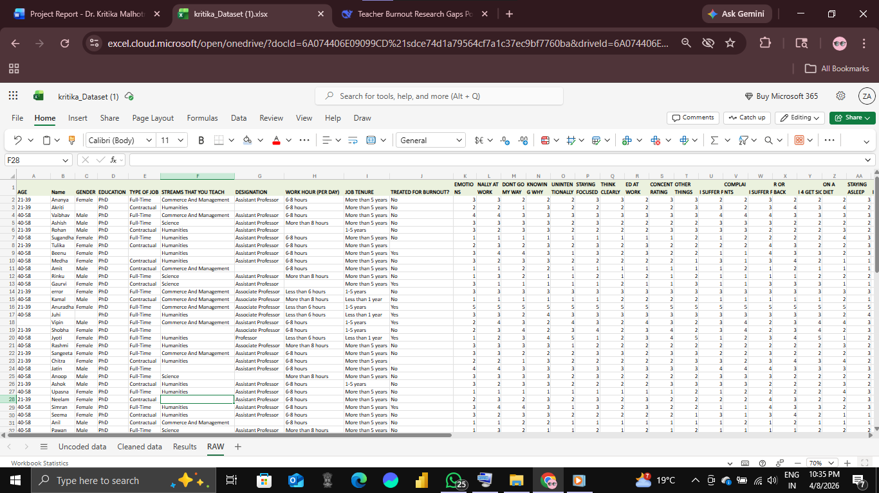

Figure 1: Raw Dataset

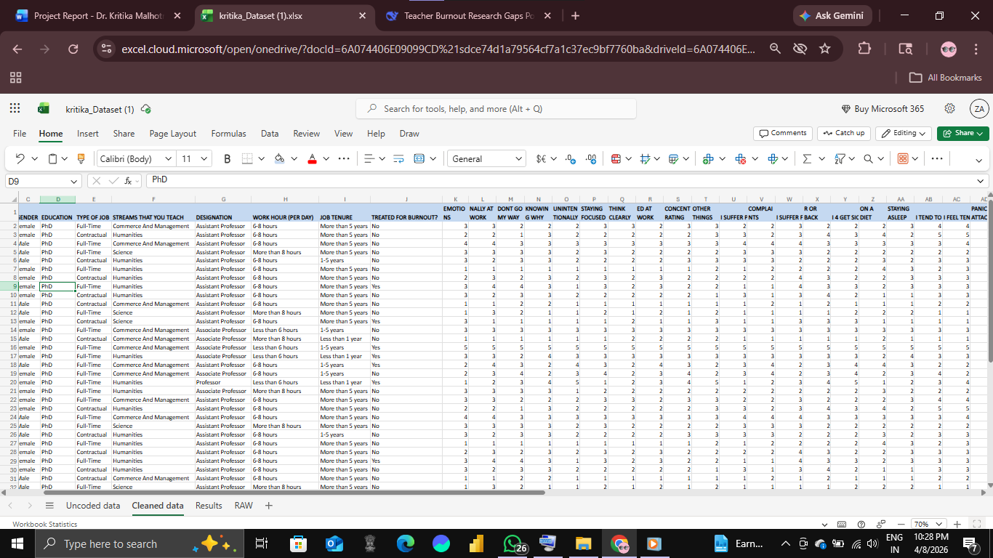
Figure 2: Cleaned Dataset
4.2 Visualization / Output Results

Scale Reliability Statistics
Scale | Cronbach’s Alpha (α) | No. of Items | Interpretation
Overall BAT Scale | 0.82 | 33 | Good Reliability
BAT-C (Core Dimensions) | 0.997 | 23 | Excellent Reliability
BAT-S (Secondary Dimensions) | 0.929 | 10 | Excellent Reliability
Table 3 : Cronbach Alpha

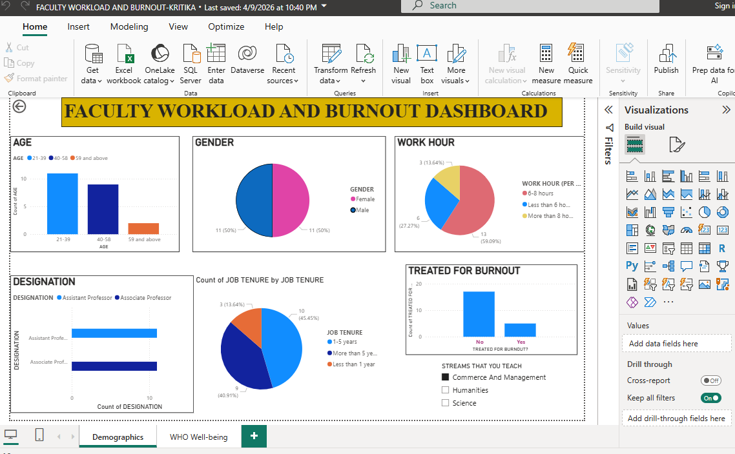

Figure 3: Power BI Demogrpahics Dashboard

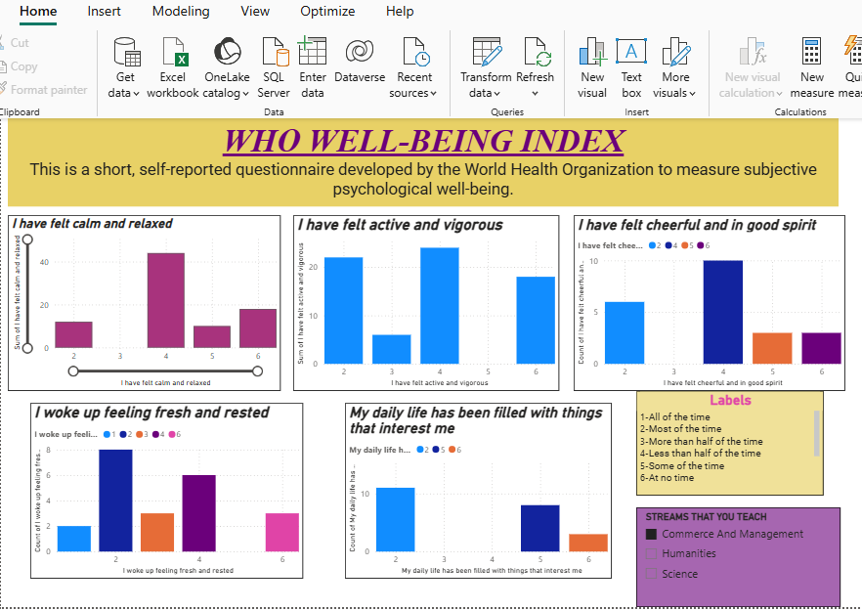
Figure 4: Power BI WHO Well-Being Index Dashboard

4.3 AI Tool Integration Results
- Tool Used:
Power BI, Microsoft Copilot and AI chatbot tools (such as ChatGPT) were used to assist in data analysis, interpretation, and content generation throughout the project.
- Prompts Used:
  - “Interpret Cronbach’s Alpha results and explain reliability in SPSS format.”
  - “Write a literature review on teacher burnout using BAT and include research gaps.”
  - “Generate ANOVA interpretation for burnout factors across academic streams.”
- Output Quality:
The AI-generated outputs were clear, structured, and academically relevant. The responses provided accurate explanations, proper formatting, and helped in generating well-written content suitable for reports. The outputs required minimal editing and were highly useful for understanding statistical concepts and improving the overall presentation of the project.
- How It Enhanced the Project:
The use of AI tools significantly improved the efficiency and quality of the project. It helped automate content writing, simplify complex statistical interpretations, and generate insights quickly. AI reduced manual effort, minimized errors, and supported faster decision-making. Additionally, it enhanced the clarity and professionalism of the final report, making the analysis more comprehensive and insightful.
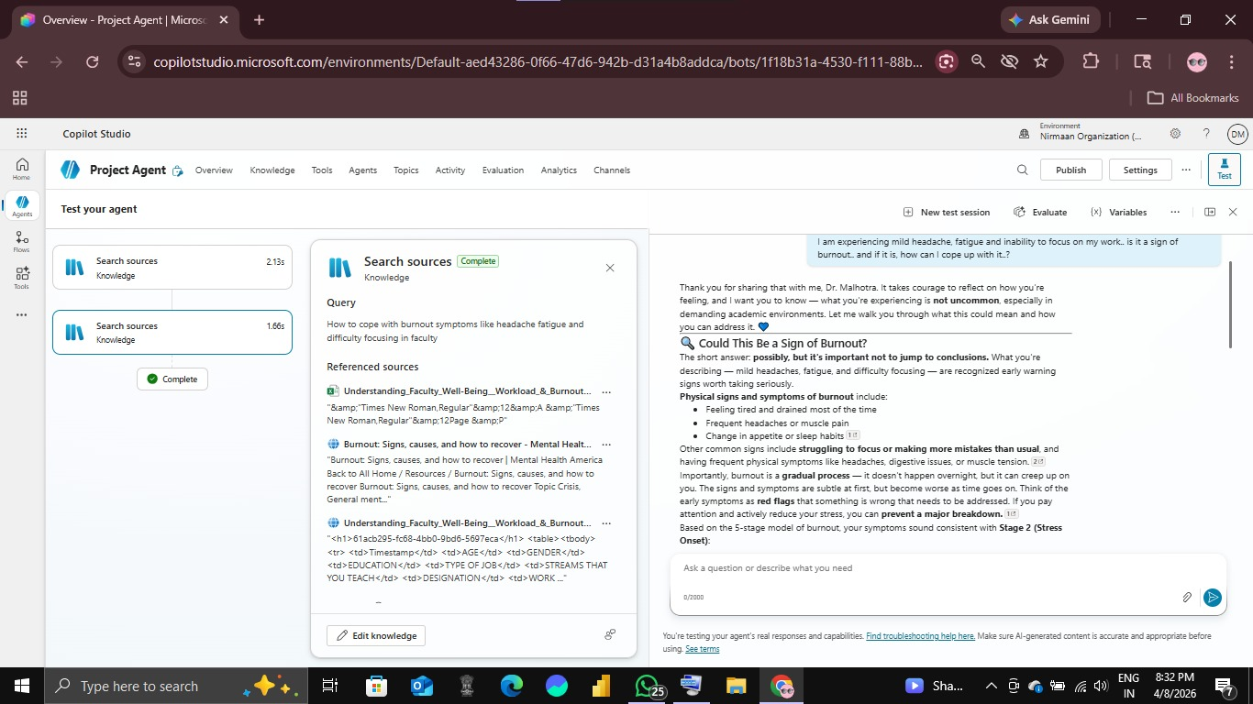
Figure 5: Chatbot Agent

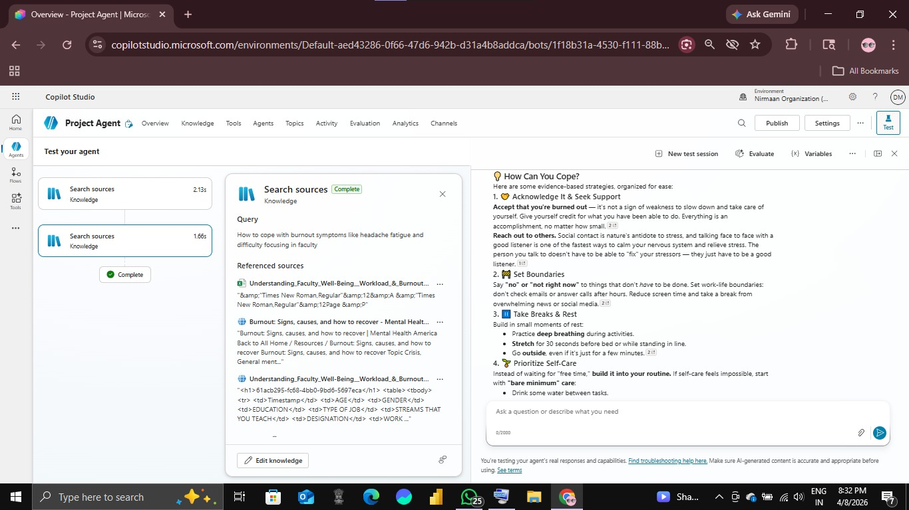

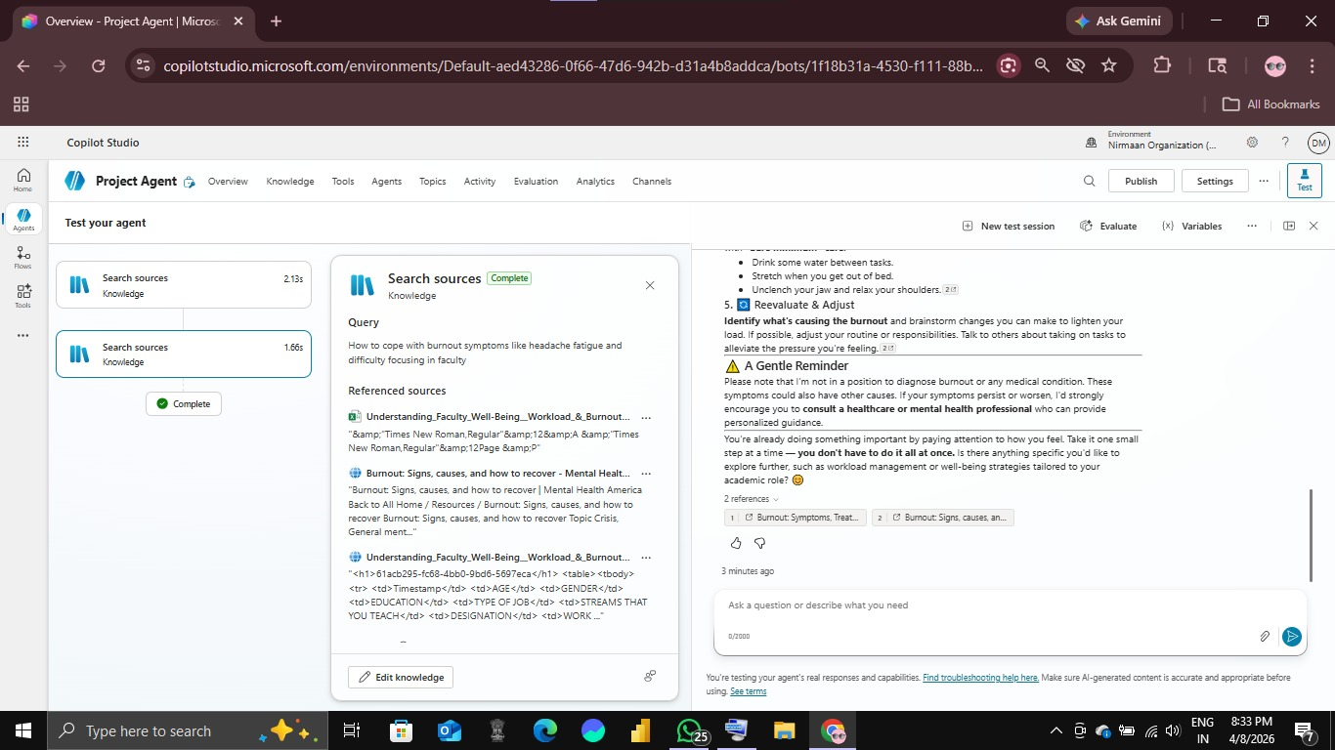
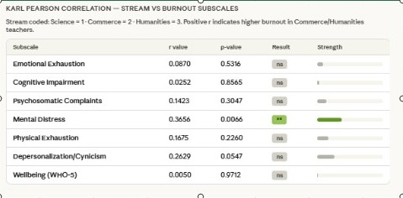
Figure 6: Correlation between BAT Vs. Stream
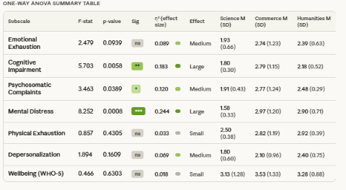
Figure 7: ANOVA
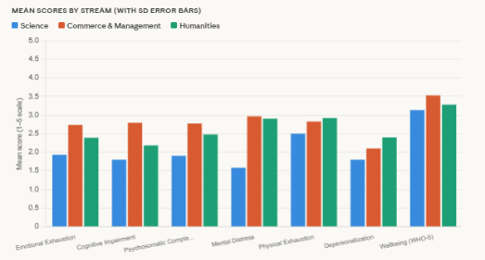
Figure 8: Mean Scores
CHAPTER 5
Discussion and Conclusion
5.1 Key Findings
- The data cleaning process improved the overall quality of the dataset by reducing the sample size from 68 to 54 responses, eliminating approximately 20% of invalid entries (duplicates and incomplete responses). This ensured higher accuracy, consistency, and reliability of subsequent analysis.
- Reliability testing using Cronbach’s Alpha (α = 0.82) indicated good internal consistency, confirming that the dataset is statistically reliable. Furthermore, both BAT-C (core symptoms) and BAT-S (secondary symptoms) demonstrated strong reliability, validating the effectiveness of the Burnout Assessment Tool in this context.
- The analysis confirmed that burnout is a multidimensional construct, with key contributing factors including mental distress, cognitive impairment, and psychosomatic complaints, rather than being limited to a single dimension like exhaustion. Hypothesis for Pearson Correlation
- Karl Pearson’s Correlation Coefficient-
H₀₁ (Null Hypothesis): There is no significant relationship between burnout dimensions (as measured by BAT) and teachers’ well-being and academic stream.
H₁₁(Alternative Hypothesis): There is a significant relationship between burnout dimensions (as measured by BAT) and teachers’ well-being and academic stream.
Pearson correlation analysis revealed a significant positive relationship between teaching stream and mental distress (r = 0.3656, p = 0.007), indicating that Commerce and Humanities teachers experience higher levels of stress, anxiety, and disturbance, while Science teachers report the lowest levels.
- Hypothesis for ANOVA (Group Differences)
H₀₂ (Null Hypothesis):There is no significant difference in burnout levels among teachers across different academic streams (Science, Commerce, Humanities).
H₁₂ (Alternative Hypothesis):There is a significant difference in burnout levels among teachers across different academic streams.NOVA analysis provided deeper insights, identifying statistically significant differences across streams in:
- Mental Distress (F = 8.252, p < 0.001, η² = 0.245 → large effect)
- Cognitive Impairment (F = 5.703, p = 0.006, η² = 0.183 → large effect)
- Psychosomatic Complaints (F = 3.463, p = 0.039, η² = 0.120 → medium-large effect)
- Post-hoc comparisons showed that Science teachers consistently reported significantly lower burnout, while Commerce and Humanities teachers exhibited higher and similar levels, especially in mental distress.
- Some burnout dimensions such as emotional exhaustion, depersonalization, and physical exhaustion were not statistically significant, although they showed emerging trends, suggesting potential relevance in larger samples.
- The findings demonstrate that ANOVA is more effective than correlation analysis in identifying group differences, as it does not rely on linear assumptions and can detect variation across multiple categories.
- The WHO-5 Well-Being Index indicated moderate levels of well-being overall, but lower scores in areas such as freshness, relaxation, and vitality were observed among high-burnout groups, reinforcing the inverse relationship between burnout and well-being.
- The use of AI tools (Microsoft Copilot and chatbots) significantly enhanced the efficiency of the project by reducing analysis and reporting time, improving interpretation quality, and assisting in generating structured academic content.
- Power BI visualizations played a key role in presenting burnout patterns clearly, enabling easier interpretation of complex data and supporting data-driven decision-making for stakeholders.
5.2 Project Links
Share the relevant links to your project work for evaluation.
- GitHub Link of the Project: [Paste your GitHub repository link here]
- Video Recording of Project Demonstration: [Paste your YouTube / Google Drive / OneDrive video link here]
- Power BI / Dashboard Link (if applicable): [Paste published dashboard link here]
5.3 Limitations
• The study is based on a relatively small sample size of 54 respondents, which may limit the generalizability of the findings to a larger population.
• Data was collected through self-reported questionnaires, which may introduce response bias or inaccuracies due to subjective perceptions.
• The research is limited to a specific geographic area (Lucknow), which may not fully represent burnout levels in other regions or institutions.
• The use of cross-sectional data restricts the ability to analyse changes in burnout levels over time.
• Microsoft Copilot and other AI tools had limited access and dependency, which may have constrained some advanced AI-based analysis features.
• The analysis does not include real-time data integration, as the dataset is static and collected at a single point in time.
• Advanced predictive models (such as machine learning) were not implemented due to scope limitations.
5.4 Future Work
- Integrate real-time data pipelines using tools like Power Automate or API connections to enable continuous data collection and live monitoring of burnout levels.
- Apply advanced machine learning techniques such as predictive modeling, trend analysis, and anomaly detection to identify early warning signs of burnout.
- Develop a user-friendly web-based interface or Power Apps solution to allow non-technical users (e.g., administrators) to easily access insights and reports.
- Expand the dataset by including a larger and more diverse sample from multiple institutions and regions to improve the generalizability of the findings.
- Add more psychological and organizational variables (e.g., job satisfaction, work-life balance, institutional support) to gain deeper insights into burnout causes.
- Implement automated reporting systems that generate periodic summaries and alerts for decision-makers.
5.5 Conclusion
This project focused on assessing occupational burnout among teachers using a data-driven and analytical approach. Burnout in the education sector is a critical issue that affects both individual well-being and institutional performance. To address this, the study utilized a structured dataset collected through a questionnaire and applied the Burnout Assessment Tool (BAT) along with supporting measures such as the MBI-ES and the WHO-5 Well-Being Index.
The project involved data cleaning, preprocessing, statistical analysis, and visualization using tools such as Microsoft Excel, IBM SPSS, Power BI, and AI platforms like Microsoft Copilot. Key analyses included reliability testing using Cronbach’s Alpha, correlation analysis for validity assessment, and ANOVA to examine differences across academic streams. The findings indicated that the dataset demonstrated good reliability, and burnout was identified as a multidimensional construct with varying levels across different factors. The study also confirmed the relationship between burnout and well-being, supporting the validity of the measurement tools.
All the objectives of the project were successfully achieved, including data preparation, analysis, visualization, and AI integration. The project adds value by providing a structured and data-driven framework for understanding teacher burnout, particularly in the context of Indian higher education. It also demonstrates how modern tools and AI technologies can be effectively used to enhance research quality and efficiency.
From a personal perspective, this project provided valuable hands-on experience in data analytics, statistical analysis, and the use of AI tools in research. It enhanced skills in data handling, interpretation, and visualization, while also deepening the understanding of real-world problems in the education sector. Overall, the project highlights the importance of data-driven decision-making and contributes to the development of practical solutions for improving teacher well-being.
5.6 Recommendations
- Workload Management: Redistribute workload across departments. Reduce excessive administrative burden.​
- Mental Health Support: Provide counselling services. Conduct stress management workshops. ​
- Flexible Work Policies: Introduce flexible teaching hours. Promote work-life balance initiatives.
- Regular Burnout Monitoring: Use tools like BAT periodically. Identify high-risk faculty early.
- AI-Based Monitoring Systems: Use AI dashboards & analytics Detect burnout trends in real-time.
- Faculty Development Programs: Training for stress handling & time management Professional development support.​
- Supportive Work Environment: Encourage peer support groups. Improve communication between faculty & management.​
- Wellness & Recreation Programs: Organize retreats, yoga sessions, wellness drives.
REFERENCES

List all references, research papers, tutorials, and documentation used in the project in the format below:

[1] Microsoft Corporation. Microsoft Excel Documentation. Available at: https://support.microsoft.com/en-us/excel

[2] Microsoft Corporation. Power BI Documentation. Available at: https://learn.microsoft.com/en-us/power-bi/

[3] Microsoft Corporation. Microsoft Copilot — AI-Powered Productivity. Available at: https://copilot.microsoft.com

[4] Edunet Foundation. AICW Fellowship Program Guidelines. 2026.

[5] Chang, M.-L. (2009). An appraisal perspective of teacher burnout: Examining the emotional work of teachers. Educational Psychology Review, 21(3), 193–218. https://doi.org/10.1007/s10648-009-9106-y
[6] Teles, R., Valle, A., & Rodriguez, S. (2020). Burnout among teachers in higher education: An empirical study of higher education institutions in Portugal. International Journal of Management Science and Business Administration, 6(5), 7–15. https://doi.org/10.18775/ijmsba.1849-5664-5419.2014.65.1001
[7] Friedman, I. A. (2000). Burnout in teachers: Shattered dreams of impeccable professional performance. Journal of Clinical Psychology, 56(5), 595–606. (Note: Verify exact publication details if required)
[8] Kabanova, E. E., Vetrova, E. A., & Kubasova, E. I. (2020). Professional burnout of faculty members of higher educational institutions. International Journal of Criminology and Sociology, 9, 2285–2290.
[9] Pakdee, S., Cheechang, P., Thammanoon, R., Krobpet, S., Piya-amornphan, N., Puangsri, P., & Gosselink, R. (2025). Burnout and well-being among higher education teachers: Influencing factors of burnout. BMC Public Health, 25, Article 1409. https://doi.org/10.1186/s12889-025-22602-w
[10] Angelini, G., Buonomo, I., Benevene, P., Consiglio, P., Romano, L., & Fiorilli, C. (2021). The burnout assessment tool (BAT): A contribution to Italian validation with teachers. Sustainability, 13(16), 9065. https://doi.org/10.3390/su13169065
[11] Schaufeli, W. B., Desart, S., & De Witte, H. (2020). Burnout assessment tool (BAT)—Development, validity, and reliability. International Journal of Environmental Research and Public Health, 17(24), 9495. https://doi.org/10.3390/ijerph17249495
[12] Maslach, C., Jackson, S. E., & Schwab, R. L. (1996). Maslach burnout inventory—Educators survey (MBI-ES). Consulting Psychologists Press.
[13] Bech, P. (2004). The WHO-5 well-being index: A short review. Quality of Life Newsletter, 32, 15–16.

